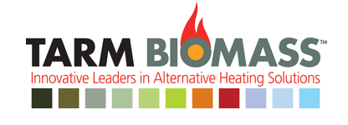

**call us: 1.800.782.9927**

* 
* 
* 
* 
* 
* 
* 

**Products**

* [Woodboilers](http://woodboilers)
  + - [Froling FHG-L](http://fhg-l)
    - [HS Tarm Solo Innova](http://innova)
    - [Scandtec Solo Plus](http://plus)
* [Pellet Boilers](http://boilers)
* [Multi-Fuel Boilers](http://boilers)
* [Heat Storage Systems](http://systems)
* [Accessories](http://accessories)
* [Discontinued Boilers](http://information)

Scandtec Solo Plus

The Solo Plus is a wood-fired gasification boiler offering 75-80% overall efficiency. The key to this process is the high temperature reached in a second refractory-lined combustion chamber. This secondary combustion consumes the creosote and smoke that normally goes up the chimney, thereby wringing every bit of energy out of the wood fuel and resulting in a very clean burn.

Three-inch vertical heat exchange tubes are sized for maximum extraction of the energy in the high-temperature exhaust stream. The Solo Plus can be used without heat storage.

The Solo Plus boiler is covered by a 20-year limited warranty.

Resources

[New! Brochure](http://www.woodboilers.com/admin/uploads/public/TA_SpecSht_SoloPlus%20reviseb.pdf)

[Product Datasheet](http://www.woodboilers.com/admin/uploads/public/SoloPlusDataSheettb.pdf)

[Plumbing Schematics Document](http://www.woodboilers.com/admin/uploads/public/WoodBoilerPlumbingSchematic0111Web.pdf)

[Product Photos](http://www.woodboilers.com/product-photos.aspx?product=42)

[Product Videos](http://www.woodboilers.com/product-videos.aspx?product=42)

[Accessories](http://www.woodboilers.com/accessories.aspx#soloplus)

[Boiler Comparison](http://www.woodboilers.com/boiler-comparison.aspx)

Specifications

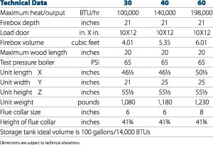

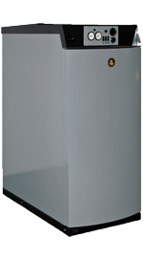

* [**Wood Boilers**](http://boilers)
* [**Pellet Boilers**](http://boilers)
* [**Multi-Fuel Boilers**](http://boilers)
* [**Heat Storage Systems**](http://systems)

**ARTICLES - Wood - Central Heat from Wood, Pellets, Corn or Coal**

**Central Heating with Wood, Coal or Pellets** (note: this article covers INDOOR approved central heating systems and does not address the Outdoor Wood Boilers (OWBs). [See this article](http://article) for more on OWBs.

Central heating has been with us for thousands of years. In fact, cities in the Roman Empire heated many public building and baths by conducting heat from a wood fire up through empty spaces under the floors.

After the fall of the Roman Empire, things actually went backwards, and early Americans 1,700 hundred years later were still using open fireplaces and vast quantities of wood to stay warm—well, actually to stay cold! It took a new revolution started by Ben Franklin (who redesigned cast-iron stoves) to finally bring some decent heating appliances to our American ancestors.

Fast forward to the late 1800s and a new fuel was discovered: Clean burning hard coal (anthracite) became the fuel of choice for a nation on the move. The old stoves were junked and coal-fired central heat was installed in virtually every home and commercial building. This continued until after WWII, when most coal units were replaced over time by oil or gas-fired boilers and furnaces.

Now we are in the midst of the “modern” stove movement, and it appears a lot of folks have forgotten about one of the BEST options for using alternative fuels: clean and comfortable Central Heat—controlled by a thermostat!

Stay warm and comfortable with Central Heating Products by [Alternative Heating of North America](http://www.ahona.com/products.html). Our products range from high efficiency indoor residential boilers to outdoor and commericial units. Accessories include plate heat exchangers, Danfoss themostatic valves and more. Declare your Energy Independence now. Dealer inquires invited!

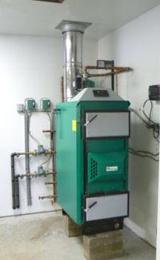

*Eko Hot Water Wood Boiler*

**Basic Definitions and Types of Systems**   
Most homes use either Hot Air (furnace) or Hot Water (boiler) as the central heating method. A furnace heats air and blows it though your home. When the thermostat senses that the desired temperature has been reached, the air stops blowing. When the house temperature drops, the furnace turns on again.

If your house has a hot water heating system (also called hydronic heat), then water is heated in an appliance called a boiler….somewhat falsely named because it does not actually boil the water, it just heats it to approximately 190 degrees F. This heated water is then pumped through the house when the thermostat calls for heat.

An important feature of modern central heating is its ability to be “zoned.” This means the home has multiple thermostats controlling different zones, allowing each part of the home to be kept at a different temperature.

So, which type of central heat is better: Hot Air or Hot Water? That depends on the situation. In warmer and more temperate areas, hot air heat can do a good job. It generally costs less to install and can be combined with an air conditioning system using the same duct work.

However, for those who want “luxury” heating, Hot Water heating represents the better choice. In fact, Hot Air heating does not even exist in many areas of Europe (where advanced heating systems are very popular). Here are some advantages of hot water heating:

1. The boiler will last for many decades because it has water surrounding it. This keeps it relatively cool so the materials are under less stress.

2. There are many heat delivery and zoning methods, from sleek and modern radiators, to old cast iron radiators, to fin and tube baseboard. One method gaining popularity is in-floor radiant heating, in which hot water is pumped through pipes or tubes under the floor. You can even tie a hot water boiler into a hot air delivery system with a heat exchanger, providing some of the advantages of both.

3. Hot water boilers can also produce domestic (bathing) hot water at a fraction of the cost of electric or gas-fired hot water.

4. Hot water boilers can store a lot of heat in the water, and can even be tied in to larger external tanks, whereas hot air furnaces must deliver the heat as it is being produced. This is important when burning wood, as most boilers will run most efficiently and burn cleanest during sustained burns at high temperatures. Hot water storage makes that possible. Hot air furnaces, by contrast, only burn at capacity when there is a call for heat.

5. Hot water can be piped for much greater distances, and with much less heat loss, than forced air. And hot water pipe takes up much less room than air ducts.

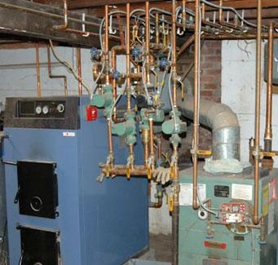

*Tarm Boiler next to oil unit*

There are two basic types of alternative fuel central heaters:

1. “Stand-alone” or “Add-on Single Fuel” burn wood, or wood/coal or corn/pellets and are installed next to your existing gas or oil system and work independently (no backup).

2. “Multi-Fuel” describes furnaces and boilers which can burn wood or wood and coal, with an oil or gas backup built into the same unit. When your wood fire dies down, the oil or gas can take over and keep your house at the proper temperature.

Within these categories, there are units which operate in various ways. For instance, most pellet and corn units are “stokers” which automatically feed the fuel into the furnace or boiler as it is needed. Coal units can be either “hand-fired” or stokers. Most wood burning systems are hand-fired.

**Cost, Installation and Other Factors**   
Installing an alternative central heating system is usually more expensive than installing a stove or fireplace insert. It is often done during the construction of a new home, so that the higher expense can be rolled into the mortgage or loan. Factors such as the chimney, access to fuel in the basement or outbuilding and the length of time you intend to stay in the house should be taken into account.

Some manufacturers insist that their boilers or furnaces be installed by a professional for the warranty to be valid. Be sure to check with the dealer or manufacturer about the warranty status if you plan to do the work yourself. Familiarize yourself with applicable codes and other requirements.

**Modern Advances**   
There are a number of clean burning central heaters on the market today, and we at Hearth.com suggest you look into models that are as efficient as possible. This will give you the most heat for your fuel, while also assuring less smoke and pollution. Most pellet, corn and coal equipment is clean by default, but hand-fired wood boilers and furnaces can run the gamut from very inefficient (less than 50%) to as high as 90% or more.

The current state-of-the-art in hand-fired wood burning is a process known as wood gasification, where the fuel is smoldered and the resulting smoke burned off at very high temperatures. Developed in Europe decades ago and rapidly gaining popularity in North America, wood gasification boilers require dry wood to operate correctly, but yield very high efficiencies and a very clean (virtually smokeless) burn. Wood gasifiers can burn a variety of fuels in addition to dry firewood, from soft coal to wood pellets to corn cobs and kernel corn.

As a rule of thumb, a wood gasification boiler will burn roughly half as much wood as a conventional wood-fired boiler for the same amount of heat. Most manufacturers recommend some form of hot water storage to accompany wood gasification boilers (500-1,000 gallons or more) and this can add significantly to the cost of the system. Make certain you carefully study the combustion system in your proposed purchase since EPA clean burning rules DO NOT apply to Central Heating. This means it is still legal to purchase and install a “smoke dragon” in many areas of the US and Canada.

**Do Your Homework**   
A Central Heating system is a large investment, and once installed you will have to live with it for a long time. Make certain you do your research before purchasing and installing. This will assure you get your money’s worth. A wealth of information is available online. Also, bear in mind that most central heating systems require electricity to operate. Some will work during power outages, but the vast majority of installations require pumps, blowers and other electrical components to operate safely. If you live in an area prone to power outages, special design considerations need to be made.

When determining the size of a Central Heating appliance, a heat-loss calculation should be made of the space being heated. This can be done by a plumbing & heating professional, or special software programs can be downloaded from the Internet for the DIY enthusiast. Particularly when using wood fuel, it is important not to oversize your boiler or furnace, since it will spend too much time idling and potentially producing creosote. Some sources of Central Heating Products:

Some sources of Central Heating Products:  
[New Horizon](http://www.newhorizoncorp.com) - High efficiency, clean burnings wood boilers - also Coal and waste wood units.  
[Energy King](http://www.energyking.com) - Hot Air and Hot Water add-on Furnaces using Wood or Pellets/Corn  
[Magnum](http://www.magnumheat.com/magnum6500.cfm) - Pellet/Corn Hot Air Furnaces  
[Greenwood](http://www.greenwoodfurnace.com) - High Efficiency Hot Water heating   
**Please rate this article by clicking once on the Like or Dislike box below:**

<---click one

* Like
* Dislike
* 46 likes
* 5 dislikes

**Article Originally Posted By:** Webmaster **On** 09/16/2007 **at** 07:57 PM



[« BACK TO MAIN ARTICLES AREA](http://www.hearth.com/what/specific.php)

[GO TO HEARTH.COM HOME](http://www.hearth.com/)